**GARMENT TRANSFOR TSHIRTS:**

**Link:** <https://lens.snapchat.com/2e3ad60aaa30433bbf4ac2cfdbf08c68?utm_source=Lens_Creator_Email>

**Codes:**

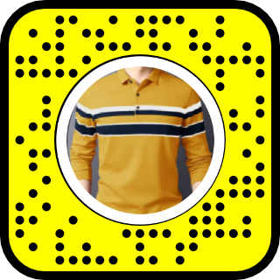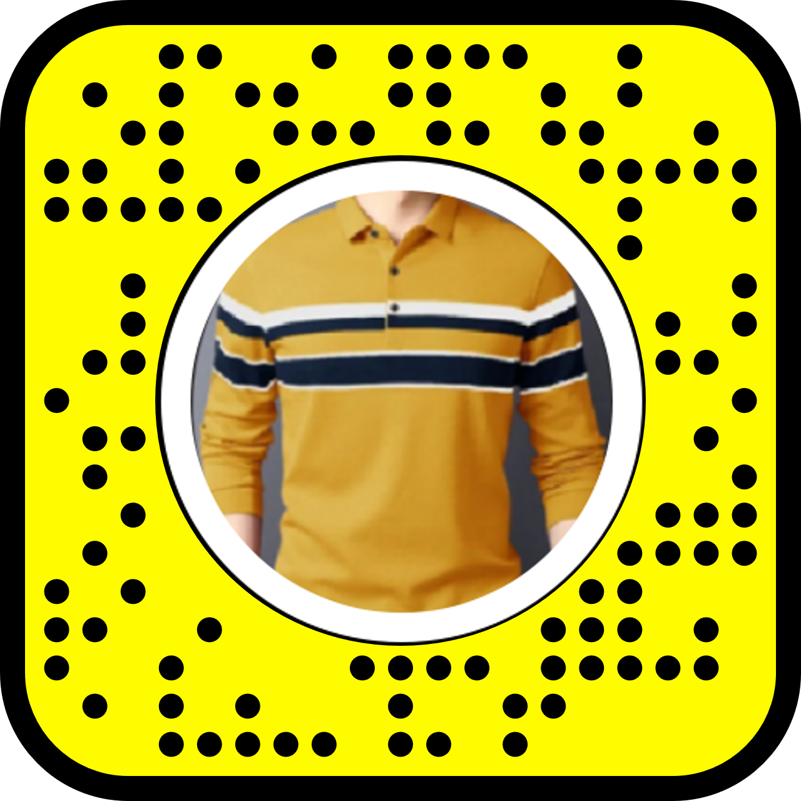

**GOLD COLOURED WATCH:**

**Link:**

[**https://lens.snapchat.com/1dfddea162474d498adc0cfedadad0c6?utm_source=Lens_Creator_Email**](https://lens.snapchat.com/1dfddea162474d498adc0cfedadad0c6?utm_source=Lens_Creator_Email)

**Codes:**

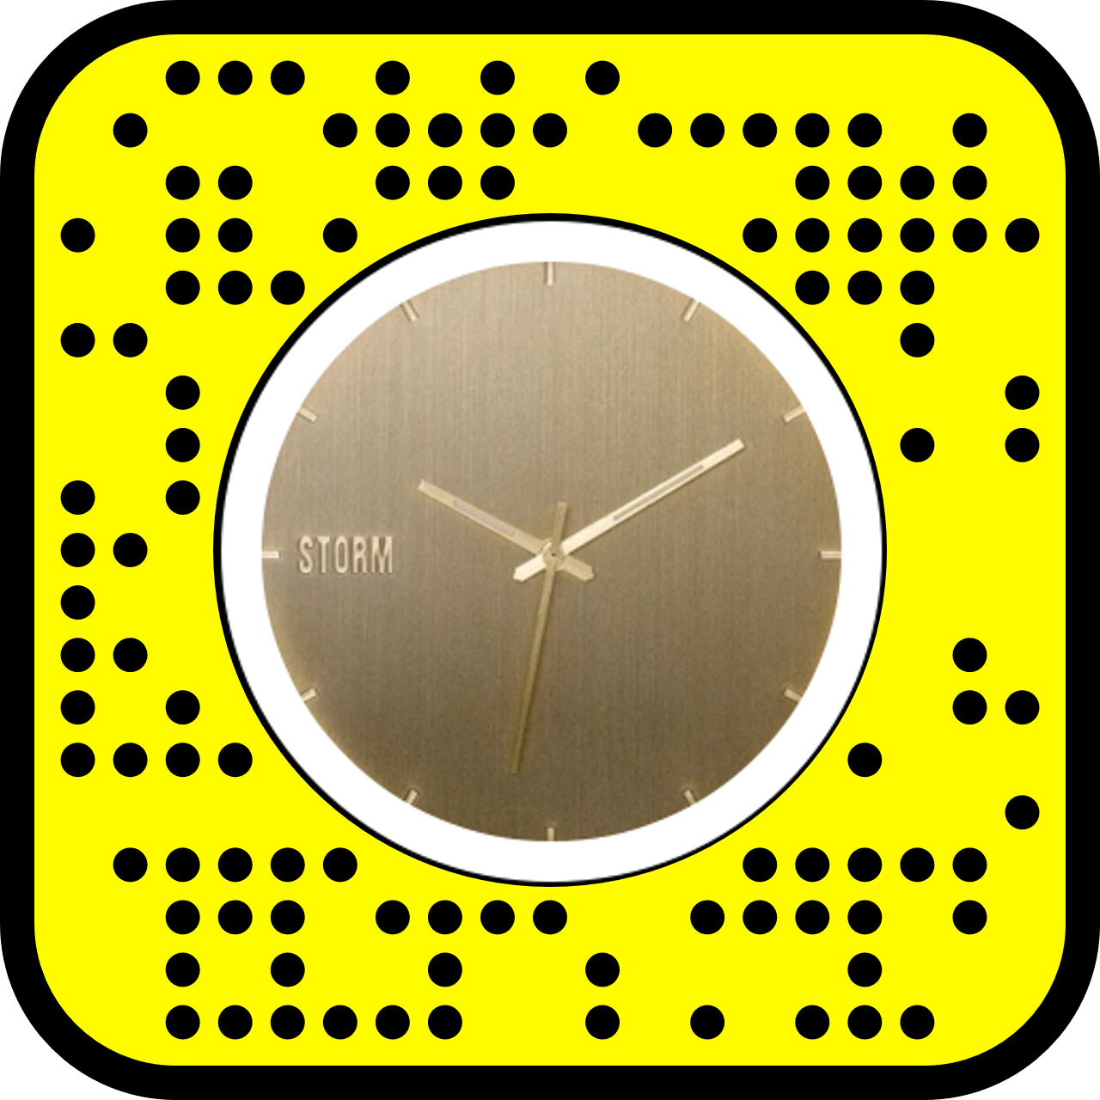

**Ebon Coat:**

**Link:**

<https://lens.snapchat.com/36394c9246b943f09ab476354771da01?utm_source=Lens_Creator_Email>

**Codes:**



**WhiteLight Hoddie**

**Link:**

<https://lens.snapchat.com/1898e50c69a74e238d74ea07a846e2be?utm_source=Lens_Creator_Email>

**Codes:**

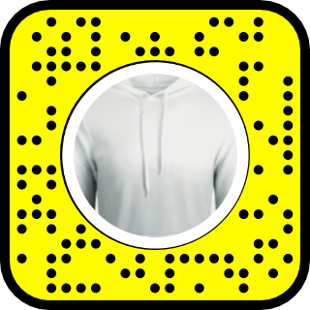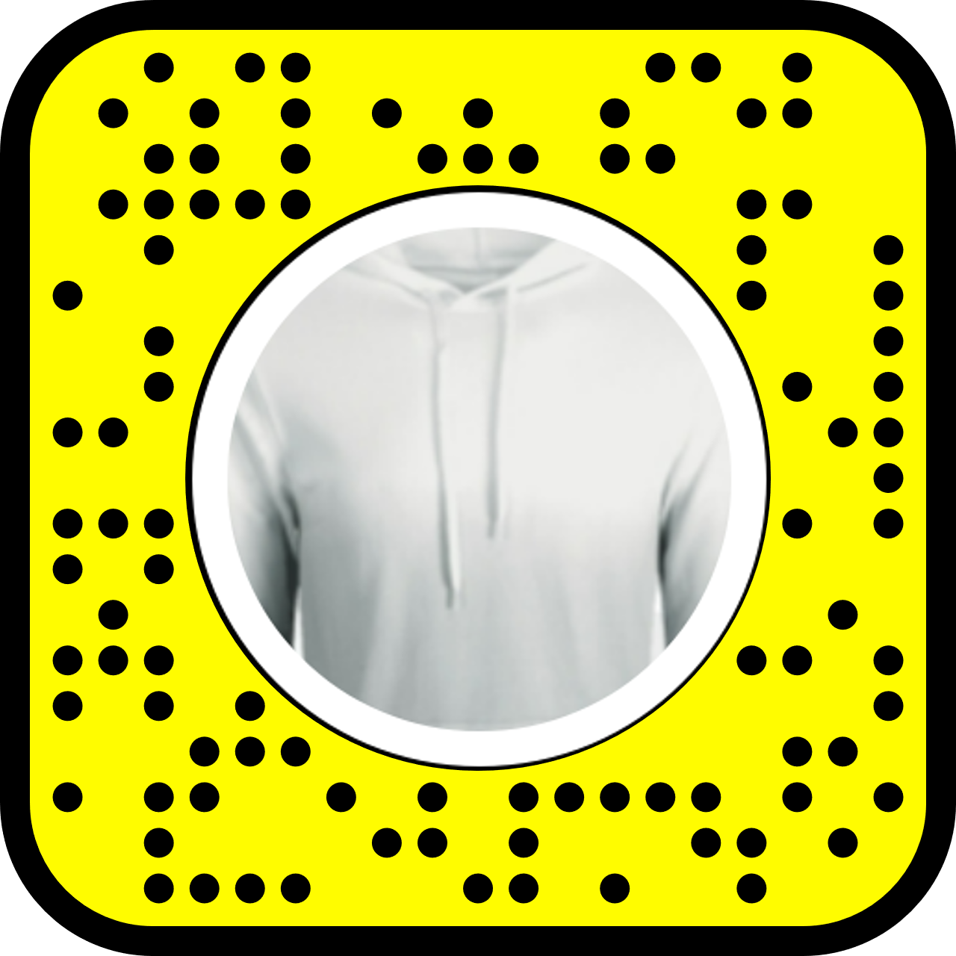

**Heliotrope Coat:**

**Link:**

<https://lens.snapchat.com/ac96853c3e454731a594250baf6f0ad1?utm_source=Lens_Creator_Email>

**Codes:**

**Denim Fabric Frock**

**Link:**

<https://lens.snapchat.com/6fc1b5b91ad648b4ba7e8799be43fe9d?utm_source=Lens_Creator_Email>

**Code:**

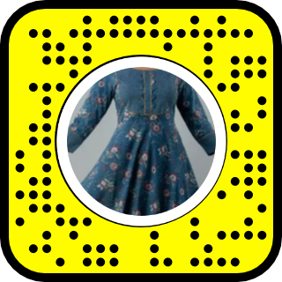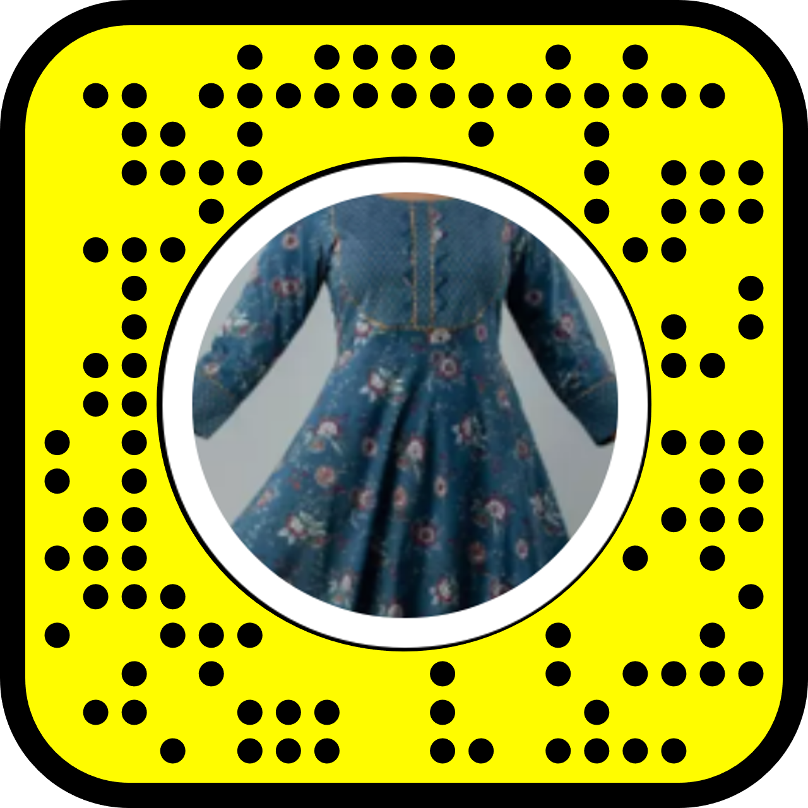

**Sparkle Huddie :**

**Link:**

<https://lens.snapchat.com/4f96505db0354496bfbd2e7abc0b37e1?utm_source=Lens_Creator_Email>

**Codes:**

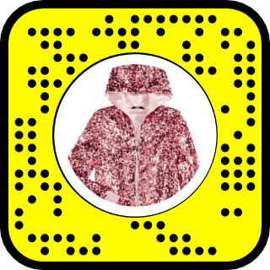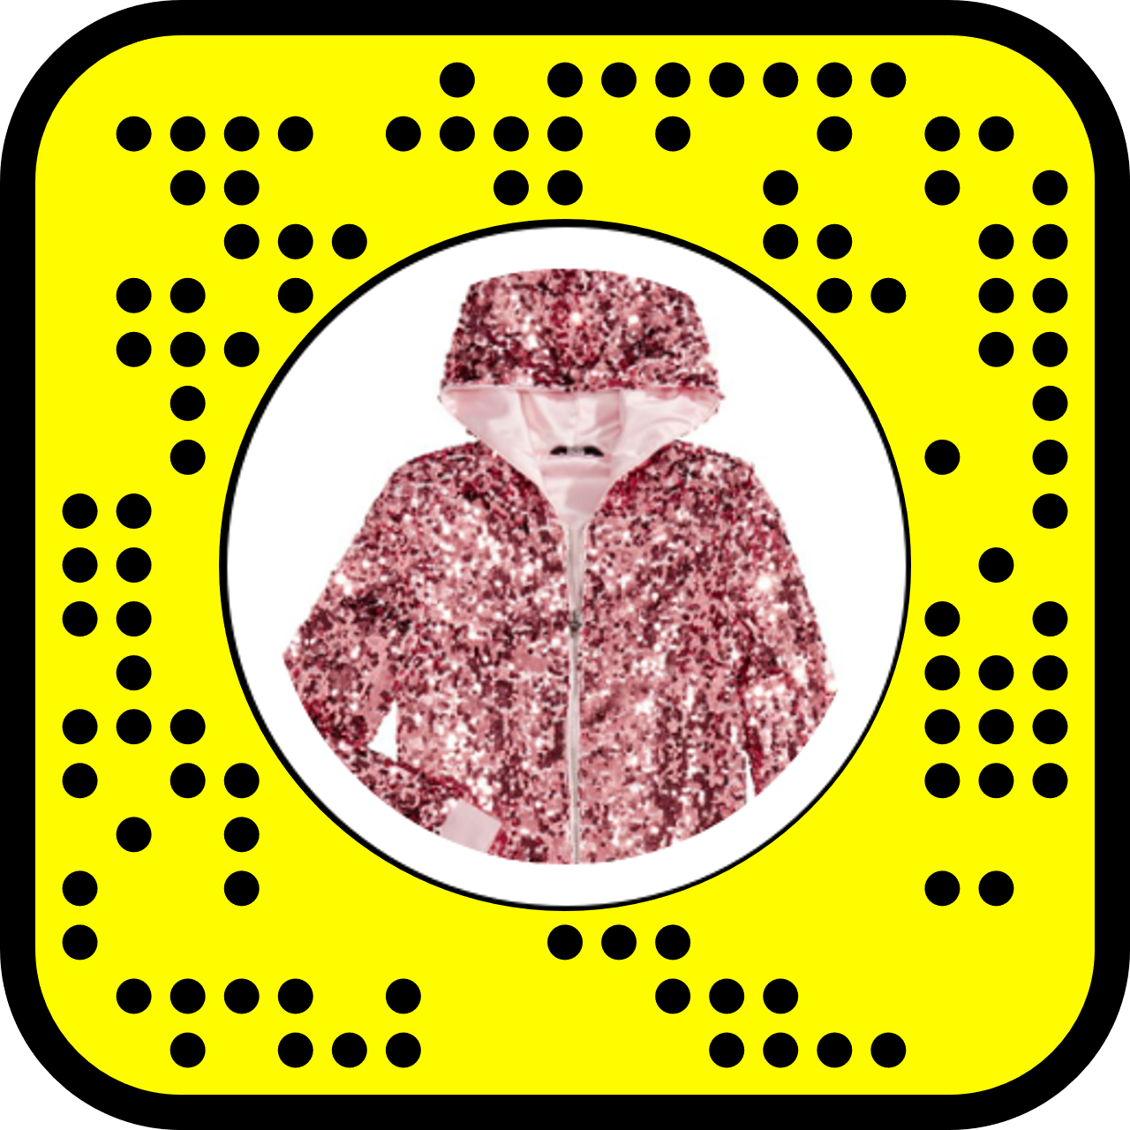

**Threader Earrings:**

**Links:**

<https://lens.snapchat.com/71b4b11ee8a246528d91220a0e4f9e97?utm_source=Lens_Creator_Email>

**Code:**

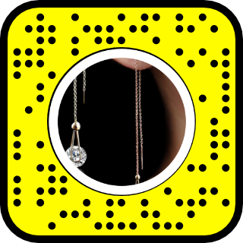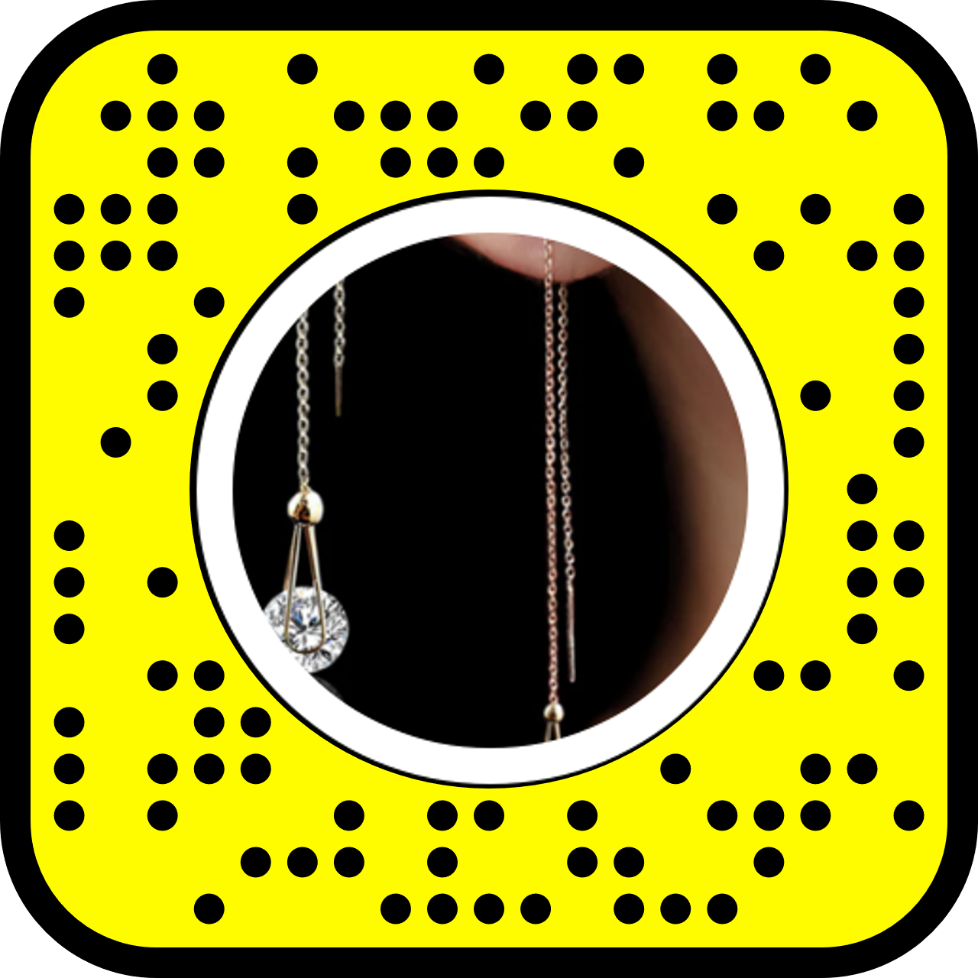

**Cartilage Earrings:**

**Link:**

<https://lens.snapchat.com/4c523b2909ea47e1a668a01c3c9d0013?utm_source=Lens_Creator_Email>

**Code:**

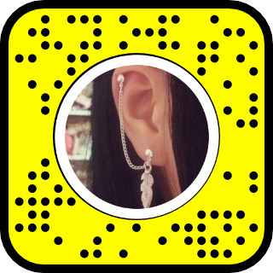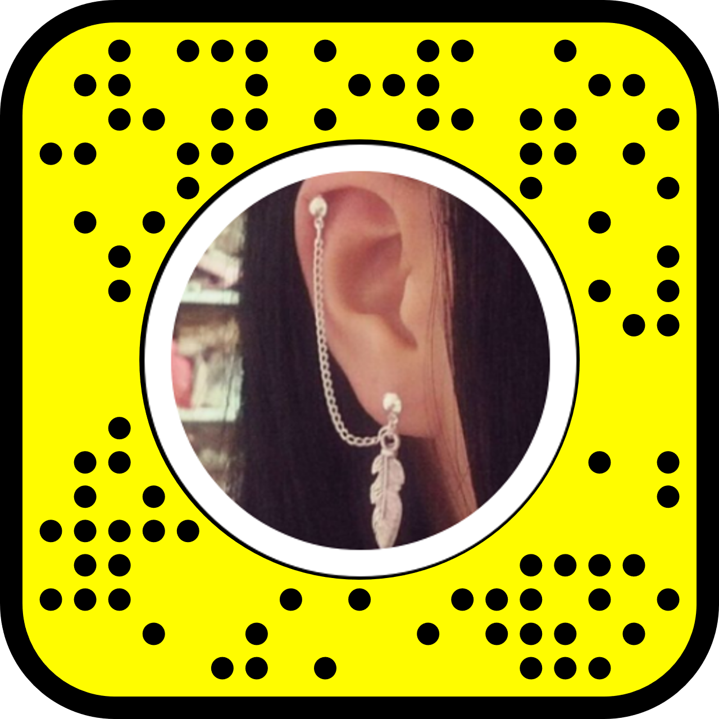

**Silver Earrings:**

**Link:**

<https://lens.snapchat.com/d1e05ed5a68f4284bceabe8a55dcee94?utm_source=Lens_Creator_Email>

**Code:**

